Activity: Create a custom ring on shapreways.com

1. Navigate to shapeways.com.
2. Register for an account if you don’t already have one.
3. Navigate to “Make Your Own” -> “Ring Creator”.
4. Navigate to “Start Customizing” with the gold ring and pattern as shown:

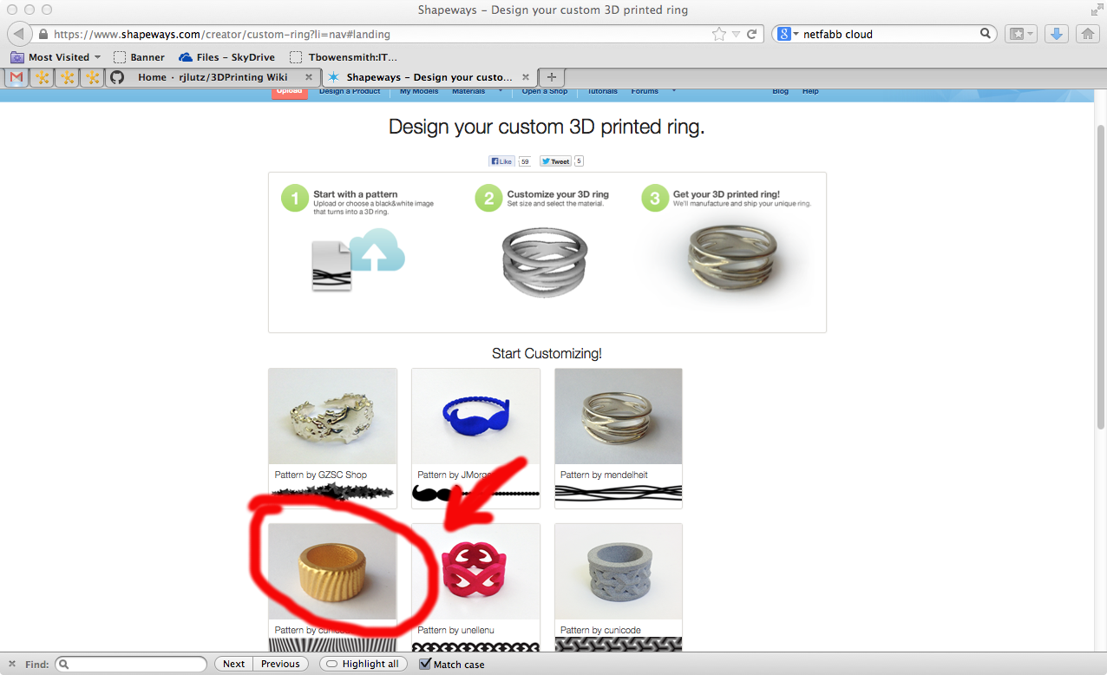

1. Right click on the zebra pattern and select ‘View Image”

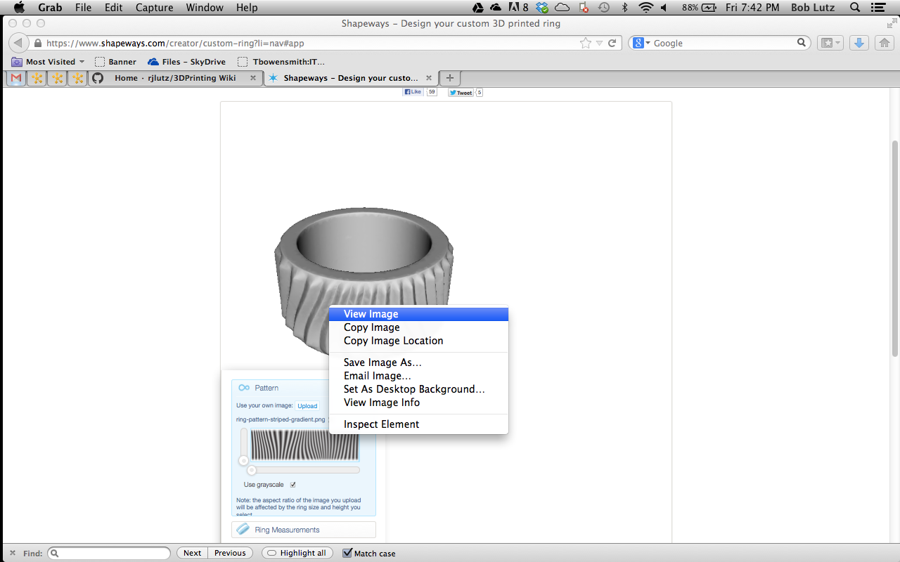

1. Save the image that appears to your local file system.
2. Open the image in your favorite image editing application (Paint, GIMP, Photoshop, etc.).
3. Add a design in with a black color on top of the background image. Be creative:

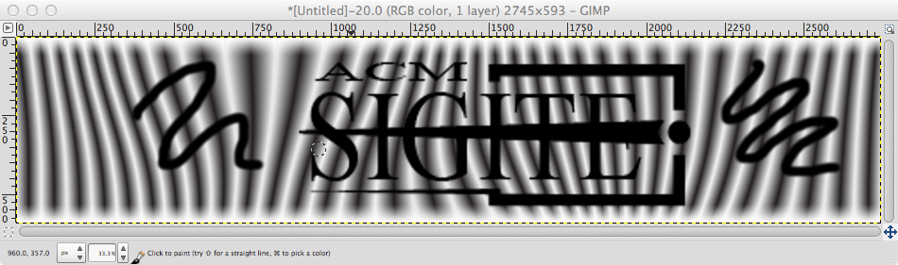

1. Optionally, you may want to add grayscale for transitions. You’ll need to experiment and may need to attempt more than one iteration to get this right.
2. Export your image to a .png format.
3. Return to the shapeways page. Update the image with your artwork:

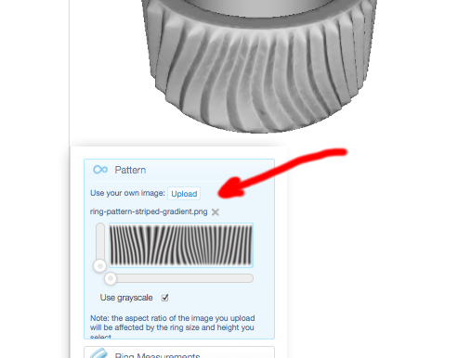

1. Examine the menu options, especially the material type. Examine the prices for different materials.
2. Make sure that there are no errors under ‘3D Printing Checks’
3. Select Add to Cart. (You should not be charged for anything yet.)
4. Wait for a confirmation email stating that the model has been created.
5. Navigate to My Models and examine your creation.

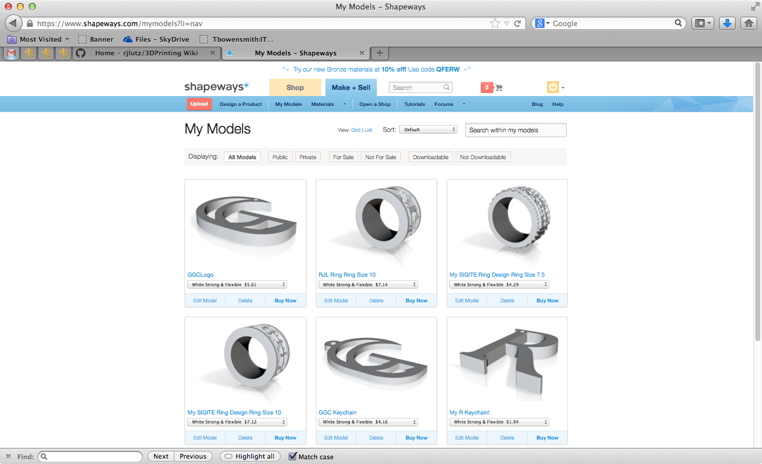

1. Optionally, click on the blue link just under your model.
2. Optionally, download your model with the Download Model button.
3. Optionally, unzip the model.
4. Optionally, download Netfabb Basic ([www.netfabb.com](http://www.netfabb.com)) and convert the provided . x3db to an .stl file.
5. Optionally, view or print your ring locally!
6. Optionally, order your ring from Shapeways! Wait for the UPS truck to arrive…